

Proposal
Smart KTM Malaysia Mobile Application

Student Name: | Chew Jie Weei
Student ID: | SCSJ2500057
Subject Code: | CIT1334
Subject Name: | Integrated Systems
Lecturer Name: | Ts. Umi Kalsum Binti Muhamad

PROJECT TITLE
Smart KTM Malaysia: Real Time Train Tracking and Passenger Monitoring Mobile Application

Table of Contents
1.0 Introduction 3
1.1 Problem Statement 3
2.0 Aim of the Project 4
2.1 Objectives of the Project 4
3.0 Literature Review 5
3.1 Real Time Tracking System 5
3.2 Mobile Transportation Application and User Acceptance 5
3.3 Key Service Quality Issues in Malaysian Rail Transit 6
4.0 Methodology 7
4.1.1 Planning Phase 7
4.1.2 Analysis Phase 7
4.1.3 Design Phase 8
4.1.4 Development Phase 8
4.1.5 Testing Phase 8
4.2 Approach 8
5.0 Project Plan 8
6.0 Conclusion 10
Reference 11

1.0 Introduction
Public transportation plays an important role in Malaysia, as many people rely on train services for daily travel, particularly in urban areas such as Kuala Lumpur and Selangor. KTM Malaysia is one of the main railway transportation providers in the country and is widely used by students, workers, and tourists due to its affordability and accessibility. However, passengers often face several issues when using KTM services, including delays, overcrowded coaches during peak hours, and difficulties in obtaining accurate train information (Khalid et al., 2014).
With the rapid advancement of mobile technology and smart transportation systems, passengers today increasingly expect faster, smarter, and more convenient transportation services through mobile applications (Biyik et al., 2021). Many users prefer to receive real-time information directly on their smartphones rather than relying on station announcements or physical ticket counters. In addition, real-time information systems have been shown to improve transportation efficiency and enhance passenger experience by providing live tracking and estimated arrival times (Ganesh et al., 2012). Furthermore, mobile-based transportation solutions are becoming an essential component of modern smart mobility systems, enabling better communication between service providers and passengers (Husnina et al., 2022).
Therefore, this project proposes the development of a Smart KTM Malaysia mobile application prototype that integrates real-time train tracking, passenger crowd monitoring, and online ticket booking features. The proposed application aims to help users track train locations more efficiently, identify less crowded coaches before boarding, and purchase tickets digitally through their smartphones. In addition, the system will focus on designing a modern and user-friendly interface using Figma to simulate a realistic mobile application experience.
The proposed application is expected to enhance passenger convenience, reduce waiting times, and support the development of smart transportation systems in Malaysia. By integrating tracking, monitoring, and ticketing functions into a single platform, the system aims to provide a more efficient, reliable, and user-friendly travel experience for KTM passengers.

1.1 Problem Statement
The development of smart transportation systems has become increasingly important in modern society, as people heavily rely on public transportation for daily travel. Mobile applications are widely used to provide users with faster and more convenient access to transportation information and services (Biyik et al., 2021). In Malaysia, KTM is one of the major railway service providers used by thousands of passengers every day. Therefore, this project aims to design a Smart KTM Malaysia mobile application that provides a more modern and interactive experience for train passengers.
Currently, some KTM passengers face difficulties in obtaining accurate train information during their journeys. Users may not be aware of the real-time location of trains, estimated arrival times, or the crowd levels in train coaches. In addition, purchasing tickets at stations can be inconvenient, especially during peak hours when long queues occur. These issues may reduce passenger comfort and negatively affect the efficiency of public transportation services (Khalid et al., 2014). Furthermore, passengers today prefer to receive real-time transportation information through mobile applications rather than relying solely on station announcements (Husnina et al., 2022).
To address these challenges, this project proposes the development of a Smart KTM Malaysia mobile application prototype that includes several smart features, such as real-time train tracking, crowd monitoring, and digital ticket booking. The application will allow users to view and monitor different trains through an interactive map interface while also displaying train status and passenger crowd levels. By integrating these features into a single platform, the proposed system aims to improve user convenience and create a more efficient and intelligent transportation experience.

2.0 Aim of the Project
Develop a Smart KTM Malaysia mobile application prototype that provides real time train tracking, passenger crowd monitoring and online ticket booking features to improve the convenience, efficiency and overall travel experience of KTM passengers in Malaysia.

2.1 Objectives of the Project
- To implement a Smart KTM Passenger Monitoring System that can estimate the number of passengers in each coach using sensors.
- To design a live train tracking feature that displays the current location of the train through a map interface.
- To implement an online ticket booking feature for KTM services through a mobile application.

3.0 Literature Review

3.1 Real Time Tracking System
Real-time passenger information is an important component of modern public transport systems as it improves operational efficiency and enhances passenger experience. Ganesh et al. (2012) proposed a real-time passenger information system that provides live vehicle tracking and estimated arrival information for passengers. The system uses GPS technology to improve transportation efficiency and reduce passenger uncertainty during travel. Through real-time updates, passengers are able to monitor vehicle locations more accurately and plan their journeys more effectively. Railway transportation services require efficient transportation management and accurate passenger information to improve passenger satisfaction and transportation efficiency (Khalid et al., 2014). In addition, smart public transportation systems can improve passenger convenience by providing digital transportation services and real-time transportation information (Husnina et al., 2022). However, the proposed system mainly focuses on tracking functions and does not include passenger crowd monitoring or digital ticket booking features. Therefore, this study proposes an improved system by integrating train tracking with additional smart transportation features into a single mobile application.

3.2 Mobile Transportation Application and User Acceptance
The effectiveness of smart transportation systems is highly dependent on user acceptance and adoption of mobile applications. Husnina et al. (2022), using the Unified Theory of Acceptance and Use of Technology (UTAUT), found that facilitating conditions such as smartphone availability and internet access, as well as user occupation, significantly influence the adoption of mobile transportation applications in the Klang Valley. The study also indicated that younger users, particularly those aged 18–29 in the private sector, are more likely to adopt such applications due to their convenience and functional benefits. In addition, Wahab et al. (2025), based on the Theory of Consumption Values, identified that functional value (reliability and punctuality) has the strongest influence on passenger satisfaction, followed by social and conditional values, while epistemic value has minimal impact. This suggests that users prioritize accurate and practical transport information over novelty features. Furthermore, Yusoff et al. (2021) reported that despite significant investment in public transportation infrastructure, private vehicle usage remains dominant in Malaysia. Khor et al. (2024) also highlighted persistent issues such as fragmented ticketing systems and poor intermodal integration, although digital payment systems and real-time data solutions have shown potential in improving system efficiency. Overall, these findings indicate that mobile transportation applications must prioritize reliability, accuracy, and integration of services to improve user acceptance and satisfaction.

3.3 Key Service Quality Issues in Malaysian Rail Transit
Existing literature consistently identifies several critical service quality issues within Malaysian rail transit systems, particularly KTM Komuter. Reliability and punctuality remain the most significant concerns, as highlighted by Bachok et al. (2013), Khalid et al. (2014) and Wahab et al. (2025), where studies show that only a small proportion of trains operate on time and passengers frequently experience delays. Capacity constraints also contribute to overcrowding, especially during peak hours, where many passengers are unable to board the first available train (Khalid et al., 2014). In addition, Masirin et al. (2017) and Khalid et al. (2014) emphasized that the fragmentation of rail systems and lack of integration between different operators create inefficiencies in passenger movement and ticketing. Information dissemination is another major issue, as passengers often receive insufficient or unclear updates during delays, limiting their ability to make alternative travel decisions (Khalid et al., 2014). Furthermore, safety and security concerns also affect passenger perception, where Wahab et al. (2025) reported issues such as vandalism and crime, while Bachok et al. (2013) identified cases of theft and harassment within rail environments. Overall, these issues highlight significant gaps in reliability, capacity management, system integration, information delivery, and safety. Although mobile-based solutions have the potential to improve these conditions, existing studies have not proposed a fully integrated application addressing all these challenges simultaneously. Therefore, this study proposes a Smart KTM Malaysia application that integrates real-time tracking, crowd monitoring, and unified ticketing to improve overall service efficiency and passenger experience.

4.0 Methodology
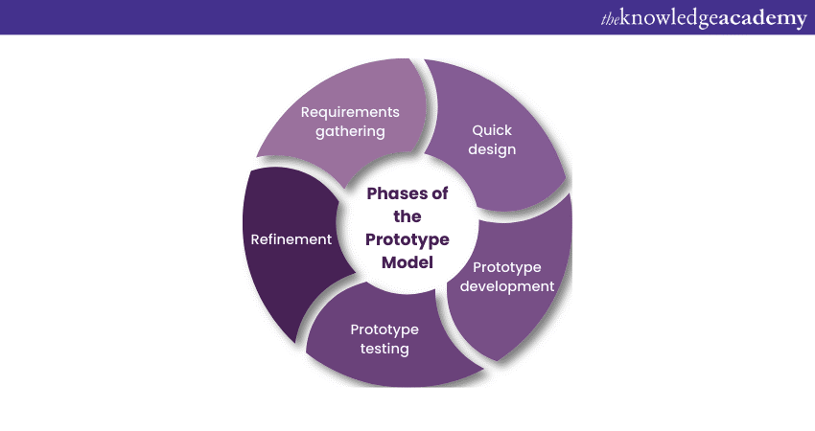
Figure 1:Phototype Model Methodology

Figure 1 shows the Prototype Development Methodology used in this project. The methodology focuses on developing an early version of the Smart KTM Malaysia mobile application to gather feedback and improve the design before actual implementation. This approach is suitable because the project mainly involves designing and evaluating a mobile application prototype using Figma. Through iterative refinement, the prototype can be improved based on user requirements and usability considerations.

4.1.1 Requirement Gathering
During this phase, information related to KTM passenger problems and transportation services was collected from journals, articles and online resources. User requirements such as real-time train tracking, crowd monitoring and online ticket booking were identified.

4.1.2 Quick Design
A preliminary design was created to visualize the system structure and user interface. Wireframes and screen layouts were prepared to represent the key features of the Smart KTM application.

4.1.3 Prototype Development
The prototype was developed using Figma. Various interfaces such as login pages, train tracking maps, crowd monitoring displays and ticket booking screens were created. Interactive navigation and animations were also added.

4.1.4 User Evaluation
The prototype was evaluated to ensure that navigation, interface consistency and usability met user expectations. Feedback was collected and improvements were made where necessary.

4.1.5 Refinement
Based on user feedback, the prototype was refined and enhanced to improve functionality, interface design and overall user experience.

4.2 Approach
This project uses a prototype-based approach to design the Smart KTM Malaysia mobile application. The approach focuses on developing an interactive mobile application prototype that improves user experience and transportation convenience. By using this approach, users are able to visualize and interact with the proposed system before actual implementation.
The prototype approach is suitable for this project because it allows the design and testing of application interfaces such as real time train tracking, crowd monitoring and online ticket booking features. In addition, the approach helps identify user requirements and improve interface usability through interactive design.
Figma software is used to create application prototypes and simulate a realistic mobile application environment. The approach focuses on creating a modern, user friendly and efficient transportation application for KTM passengers in Malaysia.

5.0 Project Plan
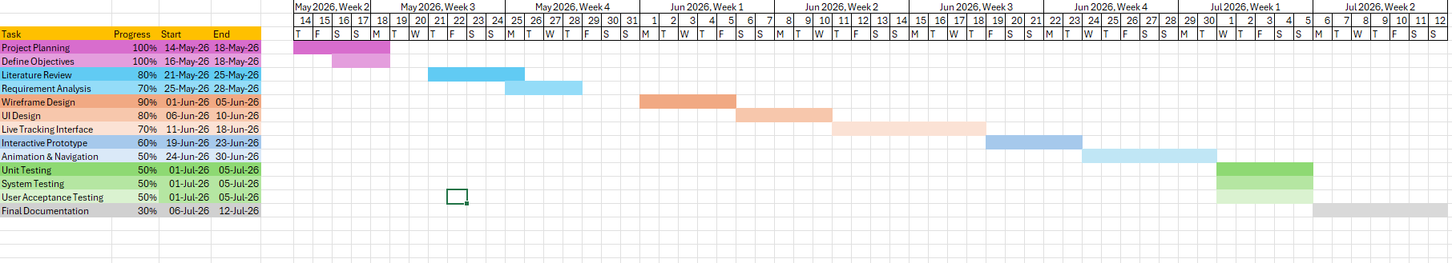
Figure 2: Gantt Chart
The development of the Smart KTM Malaysia application follows a structured timeline covering project planning, design, development, testing, and documentation phases. The project commenced on 14 May 2026 and is scheduled for completion by 12 July 2026.
The project began with the planning phase from 14 May to 18 May 2026, which included defining the project objectives. This was followed by the literature review conducted from 21 May to 25 May 2026. Requirement analysis was carried out from 25 May to 28 May 2026.
The design phase started with wireframe design from 1 June to 5 June 2026, followed by UI design from 6 June to 10 June 2026. The development phase includes the live tracking interface (11-18 June), interactive prototype development (19-23 June) and animation with navigation features (24-30 June).
Testing activities, including unit testing, system testing and user acceptance testing (UAT), are scheduled from 1 July to 5 July 2026. Finally, the final documentation will be prepared from 6 July to 12 July 2026.

6.0 Conclusion
In conclusion, this project proposes the development of a Smart KTM Malaysia mobile application prototype that integrates real-time train tracking, passenger crowd monitoring, and online ticket booking features into a single platform. Based on the literature review, KTM passengers currently face several challenges including unreliable train schedules, overcrowded coaches, lack of real-time information, and inconvenient ticketing processes. These issues negatively affect passenger satisfaction and reduce the efficiency of public transportation services in Malaysia.
To address these problems, the proposed application focuses on three main objectives. First, a passenger monitoring system will be developed to estimate crowd levels in each train coach using sensors. Second, a live train tracking feature will display the current location of trains through an interactive map interface. Third, an online ticket booking function will allow passengers to purchase tickets digitally through their smartphones, reducing the need to queue at station counters.
The project follows Prototype Development Methodology, which includes requirement gathering, quick design, prototype development, user evaluation and refinement. An interactive prototype will be created using Figma to simulate a realistic mobile application experience. The project is scheduled for completion by 12-July 2026.
Overall, the Smart KTM Malaysia application is expected to improve passenger convenience, reduce waiting times, and support the development of smart transportation in Malaysia. By integrating tracking, monitoring, and ticketing features into one platform, the system provides a more efficient, user-friendly, and modern travel experience for KTM passengers.

Reference
- Bachok, S., Osman, M. M., Khalid, U. A., & Ibrahim, M. (2013). Commuters' perceptions
on rail based public transport services: A case study of KTM Komuter in Kuala Lumpur city, Malaysia. Planning Malaysia, 11(3), 99-124.
- Husnina, S. N., Mokhtar, S., Hussein, M. Z. S. M., Hamid, Z. J. M. H., Sinniah, G. K., &
Ghani, N. A. (2022). Factors affecting mobile public transportation applications usage among urban rail transit passengers in Klang Valley, Malaysia. Journal of Computational Science and Intelligent Technologies, 1(1), 1-20.
- K. Ganesh, M. Thrivikraman, J. Kuri, H. Dagale, G. Sudhakar, & S. Sanyal. (2012).
Implementation of a real time passenger information system. arXiv preprint, arXiv:1206.0447.
- Khalid, U. A., Bachok, S., Osman, M. M., & Ibrahim, M. (2014). User perceptions of rail
public transport services in Kuala Lumpur, Malaysia: KTM Komuter. *Procedia - Social and Behavioral Sciences, 153*, 566-573.
- Khor, S. Y., Aruljodey, S., & Shanmugam, K. (2024). Digital challenges to economic
opportunities: Ubiquitous computing in Malaysia's public transportation sector. Journal of Applied Technology and Innovation, 8(2), 1-14.
- Masirin, M. I. M., Salin, A. M., Zainorabidin, A., Martin, D., & Samsuddin, N. (2017).
Review on Malaysian rail transit operation and management system: Issues and solution in integration. IOP Conference Series: Materials Science and Engineering, 226(1), 012029.
- Wahab, S. N., Hamzah, M. I., Suki, N. M., Chong, Y. S., & Kua, C. P. (2025). Unveiling
passenger satisfaction in rail transit through a consumption values perspective. Multimodal Transportation, 4(1), 100196.
- Yusoff, I., Ng, B. K., & Azizan, S. A. (2021). Towards sustainable transport policy
framework: A rail-based transit system in Klang Valley, Malaysia. PLoS ONE, 16(3), e0248519.

